Fully Automatic L-Type Sealing & Shrink Packaging Machine ZRF-450L

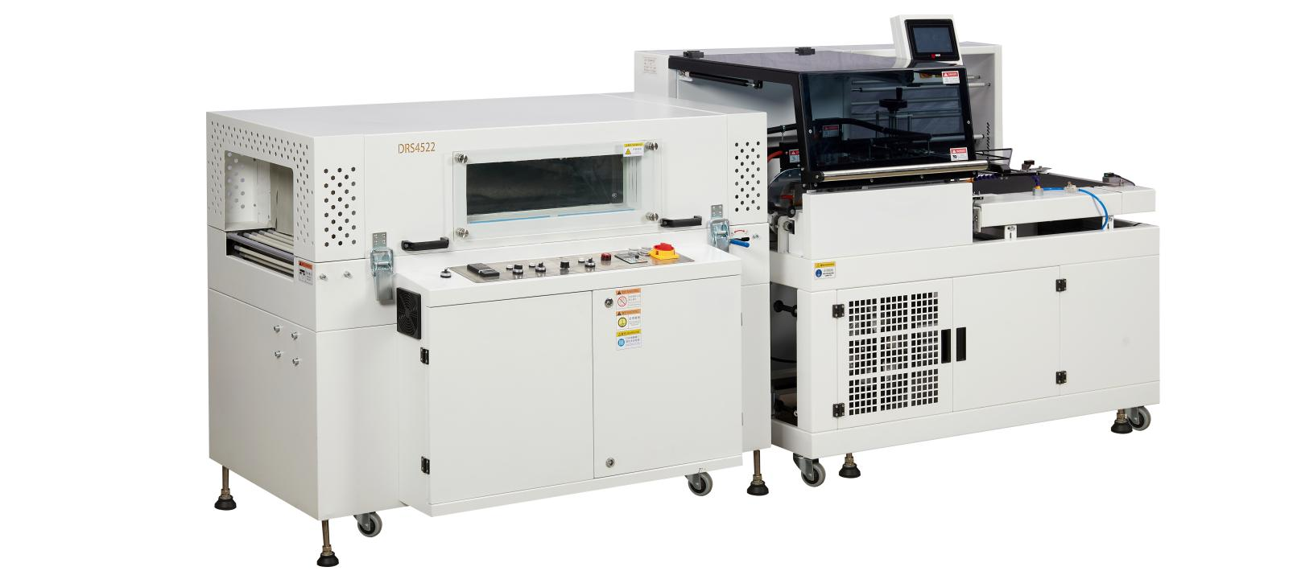
Equipment Layout：
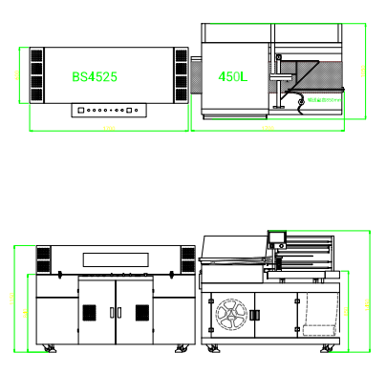
Basic Use：
Widely applicable for shrink packaging in industries including adhesive tapes, food, cosmetics, hardware, electronic components, gift boxes and other sectors.

Equipment Advantages：
- 包Maximum packaging speed reaches 15-20 packs per minute.
- The sealing & cutting station is equipped with a transparent glass protective cover, which is aesthetically neat, allows clear observation of operation, and ensures safe operation.
- The sealing knife is treated with special alloy material, featuring non-stick film performance, firm sealing, no cracking, no coking, no smoke, and zero pollution.
- Adopts imported relays to convert electrical signals into optical signals for transmission, achieving electrical isolation protection.
- Equipped with safety protection function to prevent mis-cutting of packaging films and protect operator safety.
- Manual adjustment only is required when package dimensions change; no mold replacement needed. The front/rear position and height of the worktable are adjustable, enabling convenient and easy specification changeover.
- Integrates film feeding, cutting, sealing and heat shrinking in one continuous line. It can also be connected to the feeding and sealing production line to realize unmanned operation, reduce labor cost and improve efficiency.
- Optimized film waste discharge function reduces film breakage faults, solving the frequent film breakage problem of traditional flat packaging machines.
- The shrink tunnel adopts jet-type hot air circulation system with freely adjustable temperature. Equipped with electronic speed governor for stepless speed regulation, ensuring stable conveying and excellent shrinkage effect.

Main Technical Parameters：
Model | Fully Automatic L-Type Sealing & Shrink Packaging Machine ZRF-450L | Intelligent Visible Heat Shrink Tunnel ZRS-4522
Voltage power | AC220V/1.35KW | AC380V/12KW
Package dimensions | 500（L)*330（W)*150(H) | 450(W)*200(H)
Sealing & Cutting Size Limit | L+H < 480mm, W+H < 380mm
Sealing Bar Size | 450mm*550mm
wrap | POF | PVC,POF,PE
speed/min | 18/min | 0-18/min
Machine size | 1700(L)*1050(W)*1450(H) | 18000(L)*770(W)*1150(H)
Worktable Height | 850+-50mm | 850+-50mm
Shrink Chamber Inner Size |  | 1500*450*250mm
net weight | 300KG | 150kg

Configuration Parameters：
Model | Fully Automatic L-Type Sealing & Shrink Packaging Machine ZRF-450L | Intelligent Visible Heat Shrink Tunnel ZRS-4525
PLC Controller | SANJIEILI
HMI Touch Screen | SANJIEILI
Motor | MAILI | MAILI
Relay | OMRON
Sealing Knife | SANJIEILI
Photoelectric Sensor | SANJIEILI
Pneumatic Cylinder | HENGYI
Air Filter Regulator | AIRTAC
AC Contactor |  | TIANGGAO
Circulation Fan |  | SULIN
Switch |  | TIANGGAO
Speed Governor |  | DINGJIANPAI
Temperature Controller |  | Shanghai Yatai

